Name : Sowmiya K

Reg no : 73152115071

Email id : ceecsowmiya2025@gmail.com

**SQL-DAY2 LAB**

**Retrieve all columns from the Sales table.**

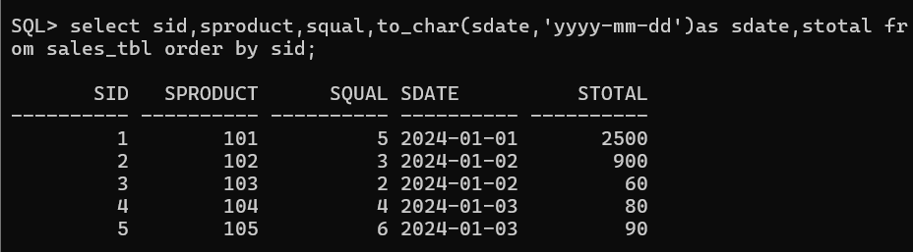

**Retrieve sale_id and quantity_sold from sales table.**

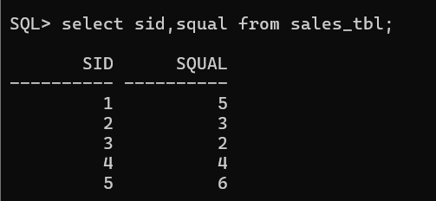

**Retrieve the sale_id and sale_date from the Sales table.**

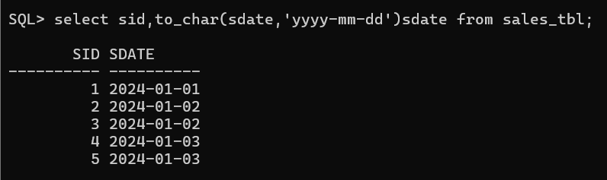

**Filter the Sales table to show only sales with a total_price greater than $100.**

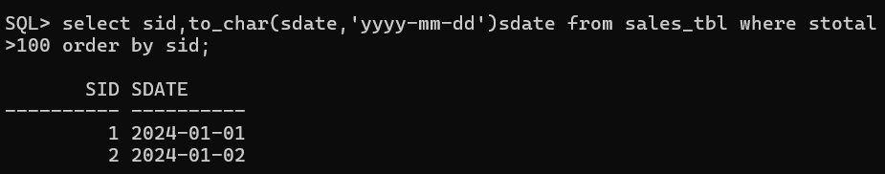

**Retrieve the sale_id and total_price from the Sales table for sales made on January 3, 2024**

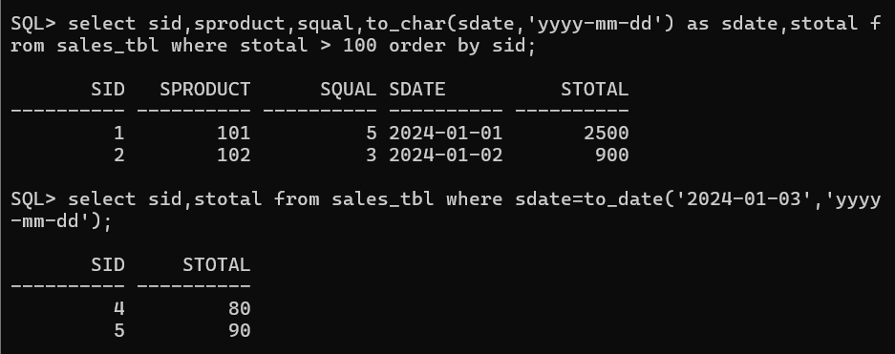

**Retrieve the sale_id, product_id, and total_price from the Sales able for sales with a quantity_sold greater than 4.**

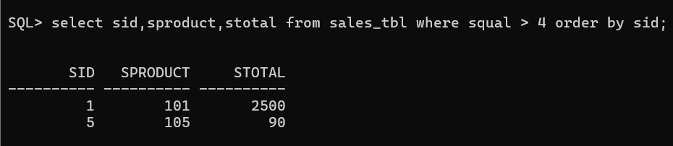

**Retrieve all columns from the Sales table those sale_id are 1, 3 & 5.**

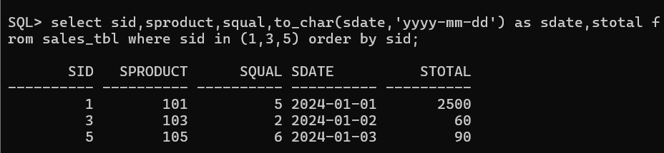

**Retrieve all columns from the Sales table those total_price between 90 and 1000.**

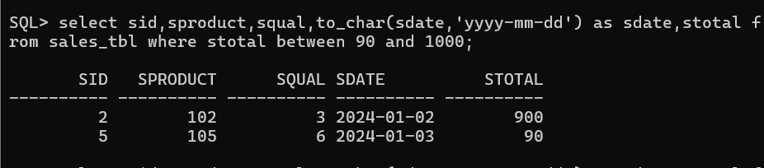

**Retrieve all columns from the Sales table those sale_id are not in 1, 3 & 5.**

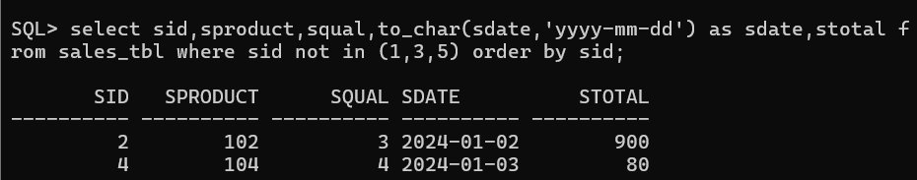

**Update total_price as 500 in the Sales table those sale_id are 1, 3 & 5**

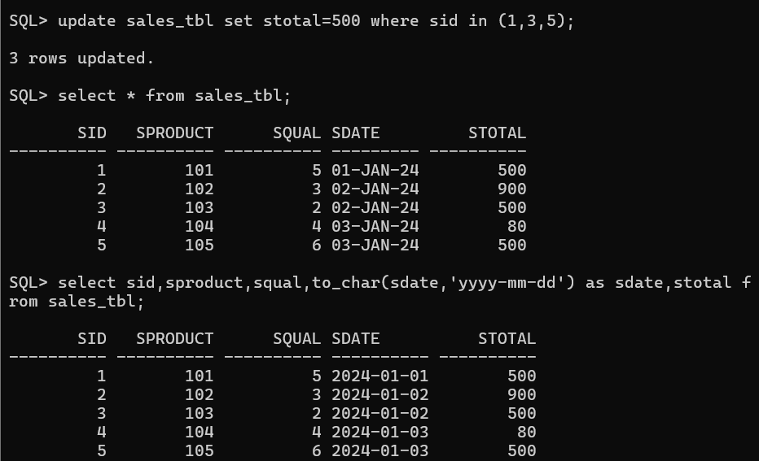

**delete from the Sales table those total_price not between 90 and 1000.**

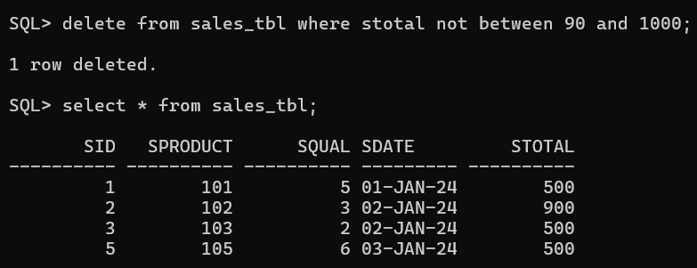

**Sort all the records using sale_id column in ascending order.**

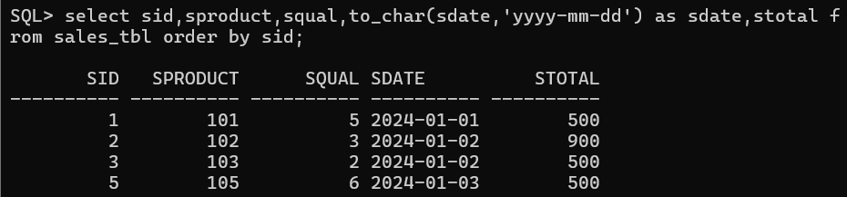

**Sort all the records using sale_id column in descending order.**

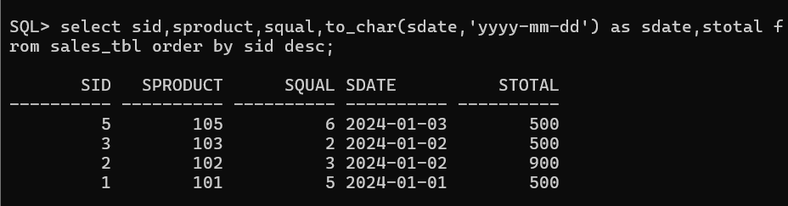

**Rename the sale_id column as sales_id**

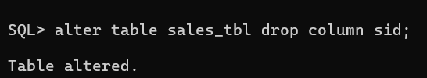

**Drop the column sales_id**

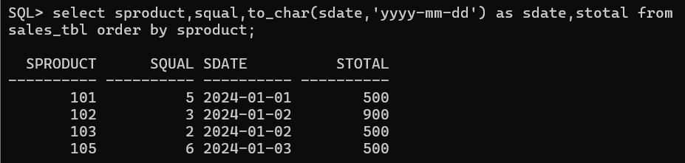

**Rename the table as tbl_sales**

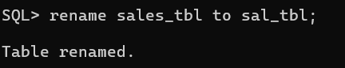

**Drop the table.**

